1. Write a program to find **GCD** (Greatest Common Divisor) and **LCM** (Least Common Multiple) of two given numbers.
2. Write a program to check if a given number is **Palindrome** number or not.

**Palindrome number:** A palindrome number is a number such that if we reverse it, it will not change. For example some palindrome numbers examples are 121, 212, 12321. To check whether a number is palindrome or not first we reverse it and then compare the number obtained with the original, if both are same then number is palindrome otherwise not.

**Palindrome number algorithm:**

1. Get the number from user. 2. Reverse it. 3. Compare it with the number entered by the user. 4. If both are same then print palindrome number. 5. Else print not a palindrome number.

1. Write a program to draw a square using character ‘**S**’. Now, modify the program to print the character **‘O’** instead of **‘S’** at the center of the square.

1. Write a program to create the following pattern:

*

*A*

*A*A*

1. Write a program for “**Guess the Number**” game.
2. **Caesar Cipher:** It is a type of substitution cipher in which each letter in the plaintext is ‘shifted’ a certain number of places down the alphabet. For example, with a shift o 3, A would be replaced by D, B would become E and so on.

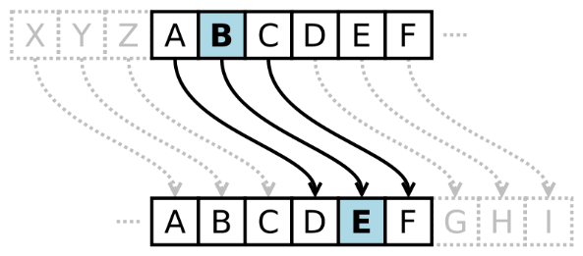

Write a C program to encrypt and decrypt a Message(String) using Caesar Cipher.

**Sample Input and Output:**

**Plain Text:** LAZY

**Encrypted Text:** ODCB

**Decrypted Text:** LAZY

1. Write a C program to find sum of first n natural numbers using recursion. Note: Positive integers are known as natural number i.e. 1, 2, 3....n
2. Dynamically allocate a variable length array using malloc and calloc. Print the content of the array in both cases. Increase size of the allocated memory using realloc.
3. Write a C function that can calculate sum of any number of integers passed to it using Variable Argument List.
4. Write a C Program to Add Two Complex Numbers by Passing Structure to a Function.
5. Write a c program to merge two files and store their contents in another file.